Day-01

- Control Flow: Iterations/Loops

Outline:
- Introduction to Loops
- For Loop
  - Iterating over a range
  - Iterating over a string
- While Loop
- Loop Control Statements
  - Break
  - Continue
  - Pass
- Nested loops
- Practical examples and common errors

Loops are control flow structures that repeatedly execute a block of code.

Loops are essential for tasks that require repeated actions, like processing data or performing calculations.
For loop: This loop is used to iterate over a sequence of elements, such as a list, tuple, string, or range. It executes the code block for each item in the sequence.
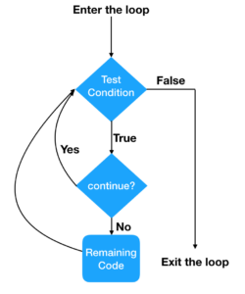

Q- Print all even number from 1 to 20
### BAD WAY!!!
print(2)
print(4)
print(6)
print(7)
print(8)
….
It is taking a lot line and increasing the code…
##Example-01 (for loop)
for i in range(5):
print(i)
This code uses a for loop to iterate through the numbers 0 to 4 (inclusive of 0, exclusive of 5).

Explanation:
- range(5) generates numbers: 0, 1, 2, 3, 4.
- The for loop assigns each number from range(5) to the variable i one at a time.
- print(i) displays the current value of i in each iteration.
The in keyword checks for membership or iterates through a sequence. In a loop like for i in range(5), it means i takes each value from range(5).

in means "take each item from the sequence (range(5)) one by one."

##Example-02 (for loop)
for i in range(1,8): ##start from the 1.
print(i)

##Example-03 (for loop)
for i in range(1,10,2):
print(i)

This loop iterates through numbers from 1 to 7, incrementing by 2 each time.

Explanation:
range(1, 8, 2) generates numbers starting from 1, ending before 8, with a step of 2.
The for loop assigns each value to i and prints it.

##Example-04 (for loop)
for i in range(10, 1, -1):
print(i)

String:
- A string in Python is a sequence of characters enclosed in quotes (single, double, or triple).
- A string is a collection of letters, characters, or data arranged in a specific order. It can include letters, numbers, symbols, or even spaces.

##Example-01 (string)
text = "Hello, world!"
print(text)

##Example-02 (string)
text = "Hello world!"
for i in text:
print(i)

Let us take other examples:

Example-01:
names = "Ali", "Ahmed", "Siraj", "Hallar"
for i in names:
print(names)

Example-02:
for i in range(6):
print(i)
else:
print("Done!")

Difference between for loop and while loop in Python:

1. for loop: Used when the number of iterations is known or to iterate over a sequence (e.g., list, range).
Example:
for i in range(5):
print(i) # Outputs: 0, 1, 2, 3, 4

2. while loop: Used when the number of iterations is unknown and depends on a condition.
Example:
i = 0
while i < 5:
print(i) # Outputs: 0, 1, 2, 3, 4
i += 1

While loop:
- While loop: Repeats as long as a condition is true. This loop executes a block of code as long as a given condition is true. The condition is checked before each iteration.

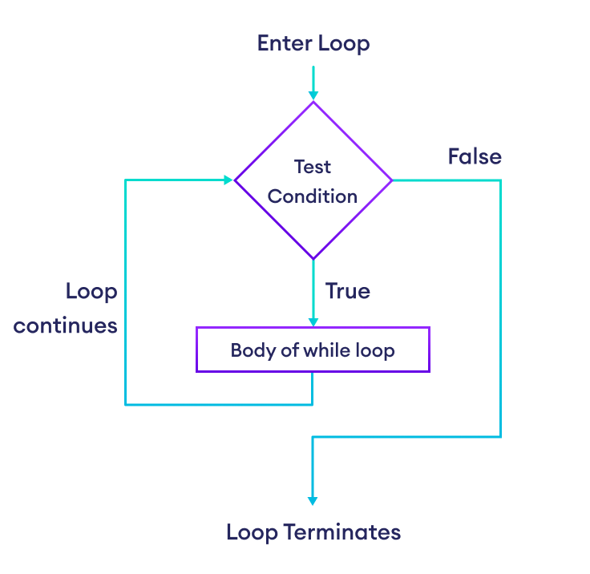

##Example-01 (while loop)
count=0
while count<5:
print(count)
count=count+1

##Example-02 (while loop)
i = 1
while i < 6:
print(i)
i+=1

##Example-03 (while loop)
count=0
while count%2==0:
print(count)
count=count+1

##Example-01 (while loop)
x = 0
while not(1<=x<=100):
x = int(input("Enter a number between 1 and 100"))
print("Valid No:" , x)

##Example-02 (while loop)
for i in range(4):
x = int(input("Enter a number between 1 and 100"))
if 1<=x <=100:
print("Valid No", x)
break
else:
print("Invalid number. Try again")

Loop Control Statements

In Python are used to control the flow of loops. There are three main types:
- break: Exits the loop immediately.
- continue: Skips the current iteration and moves to the next one.
- pass: Does nothing; acts as a placeholder.

1. break: Exits the loop immediately.
##break statement

##Example-01 (break)
for i in range(5):
if i == 3:
break #Stops loop when i is 3
print(i)

##Example-02 (break)
for i in range(10):
if i == 5:
break # Stops loop when i is 5
print(i)

2. continue: Skips the current iteration and moves to the next one.
##continue statement

##Example-01 (break)
for i in range(10):
if i%2==0:
continue # continue
print(i)

3. pass: Does nothing; acts as a placeholder.
##pass statement

##Example-01 (pass)
for i in range(10):
if i==4:
pass # pass
print(i)

Let’s try break and continue statement with another examples:
Example-01
for x in range(6):
if x == 3: break
print(x)
else:
print("Done!")

Example-02
for x in range(6):
if x == 3: continue
print(x)
else:
print("Done!")

Example-03:
i = 1
while i < 6:
print(i)
if (i == 3):
break
i += 1

Example-04:
i = 0
while i < 6:
i += 1
if i == 3:
continue
print(i)

Example-05:
i = 1
while i < 6:
print(i)
i += 1
else:
print("i is no longer less than 6")

Nested Loops.
##Try it by yourself.

